

**BINDURA UNIVERSITY OF SCIENCE EDUCATION**

**FACULTY OF SCIENCE AND ENGINEERING**

**Project Proposal - Price Comparison System**

**STUDENT NAMES:**

**MHLENGI MICHAEL MAKOMBE(Group leader)**

**VENON NYADOMBO**

**TANATSWA MSUNGWA**

**GLORIA MUGWADIK**

**REG NUMBER:**

**PROPOSAL**

* 1. **Investigation and description of current system**

A price comparison system is a software that allows users to compare prices of products across different online stores or marketplaces. The system aims to help users find the best deals and prices for the products they are interested in buying.It helps in making informed purchasing decisions.

The current system for price comparison typically involves consumers visiting multiple websites or walking into physical stores to compare prices manually. This process can be time-consuming and tedious, especially for high-priced items or when there are many options to consider.

However, there are also online price comparison websites and apps that automate this process for consumers. These platforms allow users to search for a specific product or service and compare prices from various retailers or providers in one place. Some popular price comparison websites include PriceGrabber, Shopzilla, and Google Shopping.

**1.2 Statement of the problem**

The development of a price comparison system can help individuals get the best deals and prices for products that are cheaper and are in their price range . As it is typically difficult for individuals to find a way to compare prices from different retailers without the trouble of visiting every retailer shop physically or the online store.Therefore, a price comparison system can help address this issue by providing users with the ability to easily compare prices of products across multiple retailers or websites. By inputting the desired item or product into the system, users can quickly see a list of options with their prices.The main problem that needs to be addressed in developing a price comparison system is the accuracy and reliability of the information provided. It is important to ensure that the system is regularly updated with current prices and availability in order to provide users with the most relevant and up-to-date information.

**1.3 System objectives**

* To allows consumers to see different lists of prices for the product chosen by user
* To helps consumers to make an informed decision about which to choose in order to save money.
* Help users get information about changes in prices from any supermarket at the comfort of their homes and as well gets all notifications about promotional activities.
* Provision of a platform to help either estimate or calculate one’s total expense.
* To gauge one’s budget to the price of basic goods.

**1.4 Description of the proposed system**

A Price Comparison System is a tool or platform designed to facilitate consumers in comparing prices for various products or services across different sellers or retailers. This system typically aggregates pricing information from multiple sources and presents it to users in a structured format, allowing them to easily compare prices and make informed purchasing decisions. These systems often provide additional features such as product reviews, ratings, and specifications to further assist users in evaluating their options. By offering transparency and accessibility to pricing information, Price Comparison Systems empower consumers to find the best deals and save both time and money while shopping online or in-store. Additionally, these systems can foster healthy competition among sellers, driving down prices and improving overall market efficiency.

**1.5 Limitations/Callenges of Price Comparison**

While Price Comparison Systems offer numerous benefits to consumers, they also come with certain limitations. One significant limitation is the accuracy and completeness of the data provided. Since these systems rely on data collected from various sources, including retailers' websites and third-party vendors, there may be instances of outdated or incorrect pricing information. Additionally, certain products or sellers may not be included in the comparison results, leading to potential discrepancies in the displayed prices.

Another limitation is the inability to account for additional costs such as shipping fees, taxes, or hidden charges. While Price Comparison Systems can display the base prices of products, they may not always factor in these extra expenses, potentially leading to unexpected costs for consumers.

**1.6 Scope/delimitation of the system**

The scope of a Price Comparison System outlines its operational boundaries, including the product categories covered, geographical regions served, and data sources utilized. It defines the supported retailers, available features, and considerations for data accuracy and timeliness. Moreover, it addresses the system's accessibility and its business model. This delineation helps stakeholders understand the system's capabilities and limitations, guiding its development and use effectively.

**1.7 Definition of terms**

1. **Price Comparison System**: A software application or platform designed to compare prices of products or services across multiple vendors or retailers.

2. **Vendor**: A seller or provider of products or services that is included in the price comparison system.

3. **Retailer**: A business or entity that sells products or services to consumers, which can be compared in the price comparison system.

4. **Product Database**: A centralized repository of product information, including details such as name, description, specifications, and pricing.

5. **Data Scraping**: The process of automatically extracting data from websites or online sources to gather price and product information for the price comparison system.

**Chapter 2: Requirements Specification**

**2.1 Introduction**

The requirement specification stage for the Price Comparison project is crucial for laying a solid foundation that aligns with the project's objectives and limitations. This phase is dedicated to collecting and examining the demands and anticipations of all project stakeholders, such as consumers, retailers, and administrators. The aim is to guarantee that the end product adequately satisfies their needs. Through the requirement specification process, the project is steered towards delivering a strong, intuitive, and secure platform that caters effectively to consumer needs while offering valuable insights for making informed purchasing choices. This stage will see the thorough documentation of all data, processing, software, and hardware requirements, ensuring a comprehensive blueprint for the project's development.

**2.2** **Requirement analysis**

Requirement analysis is critical to the success or failure of a system. The requirements should be documented, actionable, measurable, testable, traceable, related to identified customer's needs and defined to a level of detail sufficient for system design A Price Comparison System demands a robust infrastructure with the capability to gather, process, and present pricing data from various sources effectively. This entails a sophisticated data gathering mechanism to connect with diverse online platforms and APIs, ensuring accurate and up-to-date information for users. Additionally, the system requires advanced data processing to standardize and normalize the gathered data, providing a consistent comparison experience across different products and vendors. A user-friendly interface is vital, allowing easy search, comparison, and filtering of products based on user preferences. Interactive features such as account creation, price alerts, and user reviews further enhance user engagement. Behind the scenes, a reliable backend infrastructure with scalable servers, efficient databases, and stringent security measures is necessary to support the system's operations seamlessly.. When designing a price comparison system, there are requirements to be considered which are:

* Data requirements: The system should be able to store and retrieve product information, including prices, specifications, and reviews.
* Functionality requirements: The system should be able to compare prices and find the best deals, as well as provide users with alerts and recommendations.
* Usability requirements: The system should be easy to use and navigate, with a clear and intuitive user interface.
* Technical requirements: The system should be able to handle high volumes of data and traffic, as well as integrate with other e-commerce platforms.

**2.3 Data Requirements**

* **Product Information** - including product name, description, brand, model number, and any other relevant details.
* **Pricing Information** - including current price, sale price, promotional discounts, and any other pricing variations.
* **Retailer Information** - including retailer name, website, location, and contact information.
* **Payment Options** - including accepted payment methods, payment security features, and any additional fees or charges.
* **Comparison Tools** - such as filtering options, sorting features, and product comparison charts to make it easier for users to find the best deal.
* 6.**Data Sources** - including APIs, web scraping tools, and other data collection methods to continuously update and refresh pricing information from various retailers.

**2.4 Processing Requirements**

* Price comparison logic
* Real Time updates
* Payment Gateway
  1. **Software Requirements**
* JavaScript
* PHP
* Laravel
* Bootstrap
* MySQL
  1. **Hardware Requirements**
* Core i3 and above
* Server
  1. **Conclusion**

In conclusion, the researchers went through the requirements analysis of the system where the researchers focused on the data requirements, functionality requirements, usability requirement and technical requirement so as to see whether the system meets the requirement which is needed. The researcher also went on exploring the data requirements as well as the processing requirement which will enable the system to handle large amounts of data and processing information from multiple sources and efficiently so that users can get the information they need in time. There is also the software and hardware requirements in which the system should be designed in such way that it can run on a robust and reliable platform with the ability to scale as needed to handle increasing data and traffic processing demands. By ensuring that the system can handle these requirements, it will be able to provide users with accurate and up-to-date information about product prices and other details.

CHAPTER 3: DESIGN

3.1 INTRODUCTION

In today's dynamic and fast-paced marketplace, the ability to make informed purchasing decisions is crucial for both consumers and businesses. As the range of products and services continues to expand, so does the need for an efficient and reliable method of comparing prices across various vendors. Recognizing this growing demand, the development of the Price Comparison System (PCS) presents an innovative solution to empower users with comprehensive and real-time price information.

This chapter delves into the design phase of the PCS, where we explore the intricacies of creating a robust and user-friendly system that bridges the gap between consumers and sellers. By leveraging cutting-edge technologies and incorporating user-centric design principles, we aim to provide a seamless and intuitive experience to users seeking the best deals and optimal value for their purchases.

The design process outlined in this chapter encompasses various aspects, including system architecture, user interface design, data integration, and search algorithms. We will delve into the essential considerations and decisions made during the design phase, highlighting the key features and functionalities that make the PCS an indispensable tool for both individual shoppers and businesses alike.

.

3.2 User Interface Design

1. Search bar: A prominent search bar should be placed at the top of the page, allowing users to easily search for products by name, category, or brand.

2. Filter options: Provide users with the ability to filter search results by price range, brand, category, and other relevant criteria. This will help users narrow down their options and find the best deals quickly.

3. Product listings: Display search results in a clear and organized manner, with product images, prices, and descriptions. Include key information such as availability, shipping costs, and user reviews.

4. Comparison tool: Allow users to select multiple products and compare them side by side, highlighting key features, prices, and other important details.

3.3 Input & Output Design

Input Design:

1. Search bar: Users can input the product name, category, brand, or other relevant search terms to find the desired products.

2. Filter options: Users can input their desired price range, brand preferences, and other criteria to narrow down search results.

3. Compare tool: Users can select multiple products to compare and input specific features they are looking for.

Output Design:

1. Product listings: Display search results with relevant product information such as name, image, price, availability, shipping costs, and user ratings.

2. Comparison table: Show a side-by-side comparison of selected products, highlighting key features and prices for easy comparison.

3. Filtered search results: Display search results based on user input criteria, showing only the products that match the specified filters.

3.4 Flow Charts

The flowchart below describes the activities of the user from the launching of the Application to its closing. Firstly the user has to log in. If the user inputs the correct login parameters then he is successfully logged in and proceeds to the Main Menu.

In the main menu, the user can choose the menu option depending on the task the user intends to do. After doing the task the user saves the task and goes back to the main menu and proceeds to another task or if done can log out and exit the App.

View user profile

Display

Menu

Choose Menu Option

Manage wishlist/shopping cart

Display Login Menu

Login

Browse product/categories

logout

Return to

Menu

Save task

Database design and ERD diagrams

ER Diagram

User

stores

System

Admin

Manages

Is Controlled by

DFDs

User

system

database

retailor

product

review

DFD is often used as a preliminary step to create an overview of the System without going into greater detail. It shows how the system is divided into sub-systems (processes), each of which deals with one or more of the data flows to or from an external agent, and which together provide all of the functionality of the e_system as a whole.

DATABASE SCHEMA

***PHYSICAL LEVEL***

This is the lowest level of abstraction and defines how data is stored. Concepts at this level are meant for computer specialists and not for typical end-users.

***CONCEPTUAL LEVEL***

This level describes what data is actually stored in the database and the relationships that exist amongst the data. The data is stored in tables and a table’s design describes what it stores, that is the tables’ attributes’ specific features (integer, string, and the exact size, format). The table’s field name and data type are defined. Queries are also defined in this level and how they link with each other.

***VIEW LEVEL***

This level shows the highest level of abstraction. Its main aim is to simplify the user’s interaction with the database by the provision of interfaces that the user can simply manipulate. The database records can be viewed using forms, reports, and tables. The database manipulation is done using Structured Query Language (SQL).

Database Physical Level, Conceptual level, and View level

**External View 1**

**External View 2**

**Internal Schema**

**Conceptual Schema**

**Database**

3.5 Process Design

UML Class Diagram

The class diagram is the main building block of object-oriented modelling. It is used for general conceptual modelling of the structure of the application, and for detailed modelling, translating the models into programming code. Class diagrams can also be used for data modelling. The classes in the class diagram below represent both the main elements, interactions in the application, and the classes to be programmed

|  |
| --- |
| Price |
| -priceId: string  -productId: string  -retailerId: string  -priceValue: decimal  -currency: string  -dateOfPriceUpdate: date |
| +getPriceId(): string  +getProductId(): string  +getRetailerId(): string  +getPriceValue(): decimal  +getCurrency(): string  +getDateOfPriceUpdate(): date |

|  |
| --- |
| Product |
| -productId: string  -name: string  -description: string  -brand: string  -category: string |
| +getProductId(): string  +getName(): string  +getDescription(): string  +getBrand(): string  +getCategory(): string |

|  |
| --- |
| Retailer |
| -retailerId: string  -name: string  -address: string  -contactInfo: string |
| +getRetailerId(): string  +getName(): string  +getAddress(): string  +getContactInfo(): string |

|  |
| --- |
| PriceComprisonSystem |
| -user-Dao: user-Dao  -productDao:productDao  -retailer Dao: retailer Dao |
| +registerUser(user: User): void  +login(username: string, password: string): boolean +searchProduct(query: string): List<Product> +getProductDetails(productId: string): Product +getProductPrices(productId: string): List<Price> +addProductToWishlist(user: User, productId: string): void  +removeProductFromWishlist(user: User, productId: string): void  +getWishlist(user: User): List<Product>  +addProductToCart(user: User, productId: string): void  +removeProductFromCart(user: User, productId: string): void  +getCart(user: User): List<Product>  +postReview(user: User, productId: string, review: string): void |
|  |

|  |
| --- |
| User |
| -userId: string  -username: string  -password: string  -email: string |
| +getUserId(): string  +getUsername(): string  +getEmail(): string  +setEmail(email: string): void |

Use Case

To model the system, the most important aspect is to capture the dynamic behavior. Dynamic behavior means the behavior of the system when it is running/operating.

Only static behavior is not sufficient to model a system rather dynamic behavior is more important than static behavior. These internal and external agents are known as actors. Use case diagrams consist of actors, use cases, and their relationships. The diagram below was is used to model the system and subsystems of the application. The use case diagram captures particular functionalities of the system.

Database

User

Admin

**Activity Diagrams**

|  |  |  |
| --- | --- | --- |
| User(customer) | Decision Support System | Displaying Task Details |

User log in the system

Choose Task Option

Task will be displayed

Close

Although activity diagrams primarily show the overall flow of control, they can also include elements showing the flow of data between activities through one or more data stores.[citation needed.

Ellipses represent actions;

Diamonds represent decisions;

Bars represent the start (split) or end (join) of concurrent activities;

A black circle represents the start (initial node) of the workflow;

An encircled black circle represents the end (final node).

Arrows run from the start to the end and represent the order in which activities happen.

**3.6 Conclusions**

This chapter focused on the design of the system and its supposed operations that must bring the intended results. More diagrams were used in the illustration process for better understanding. The above designs were used to implement the code to develop the system.

# **Chapter 4**

## **4.1 Introduction**

This chapter is dedicated to exploring the coding and testing phase of our Price Comparison System. This chapter will delve into the technical documentation of our system's code, discuss the strategies and results of both unit and system testing, and provide insights from user testing sessions.

## **4.2 Technical Documentation: System Code**

This section offers an in-depth look into the architecture and workings of our system's codebase. It includes:

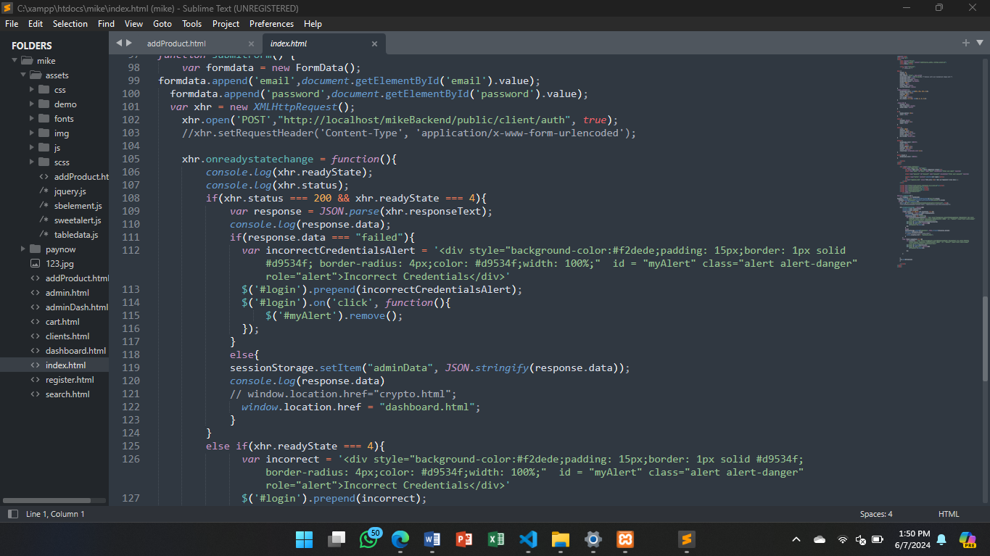

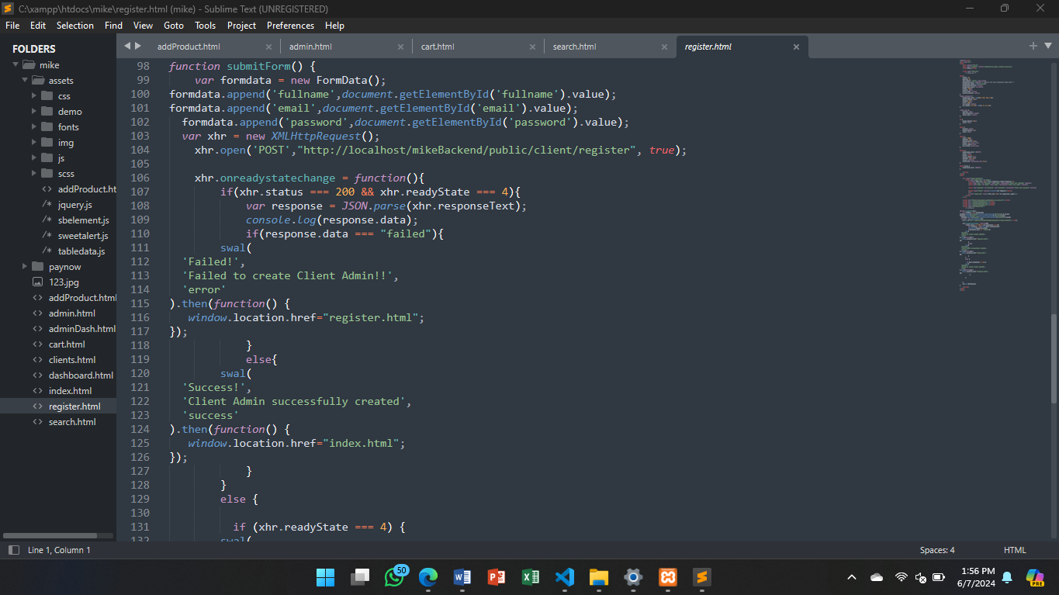 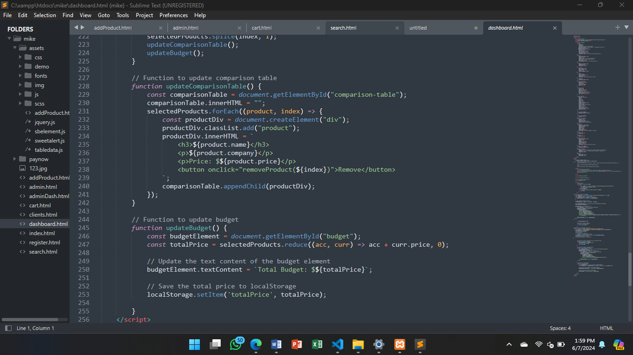 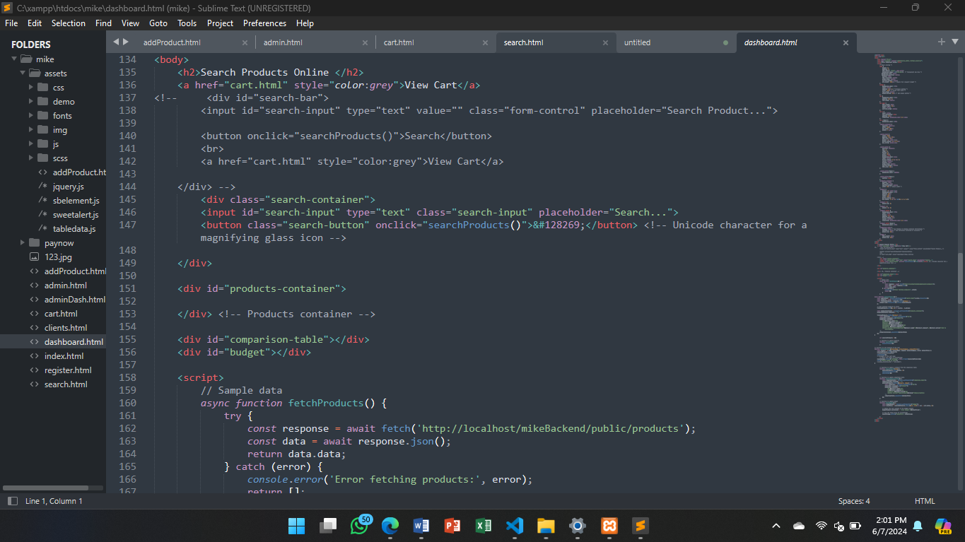 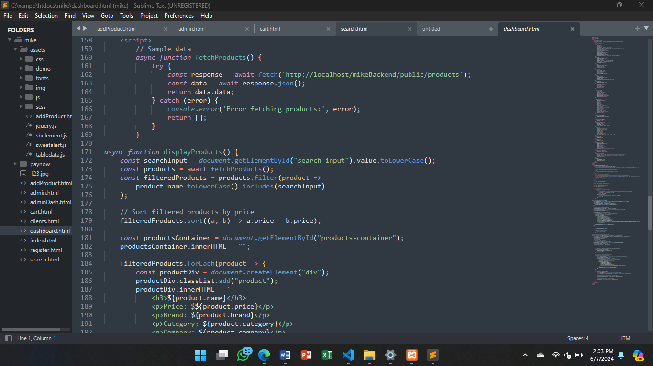 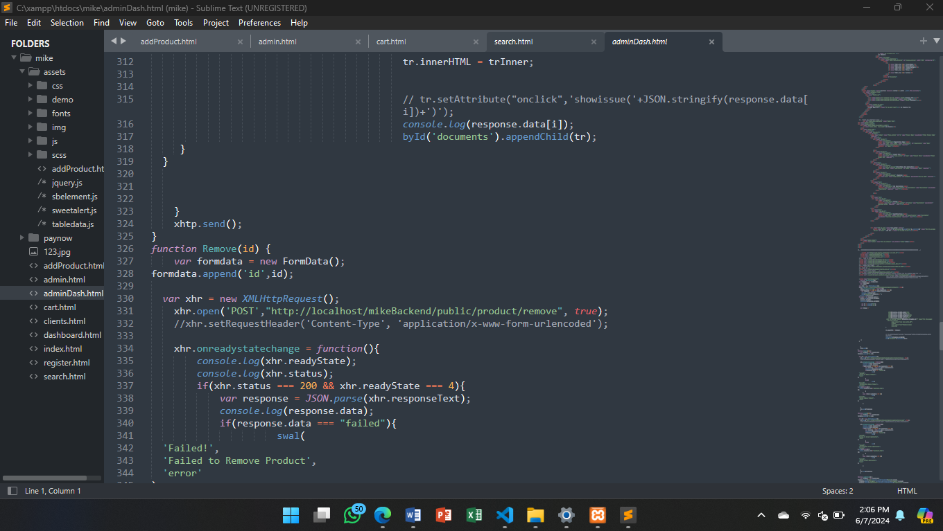 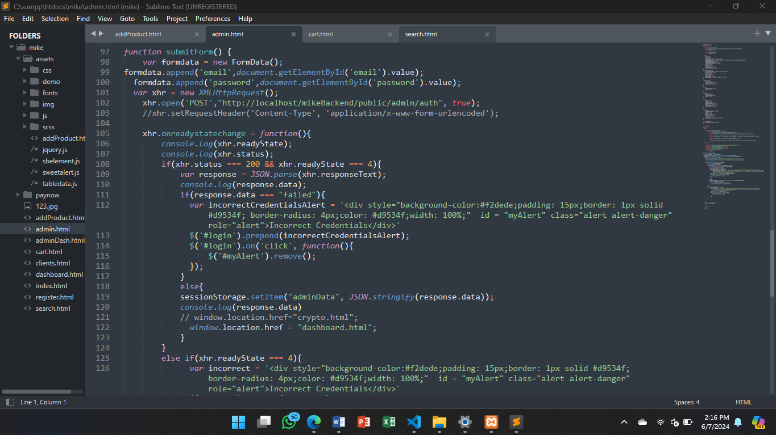 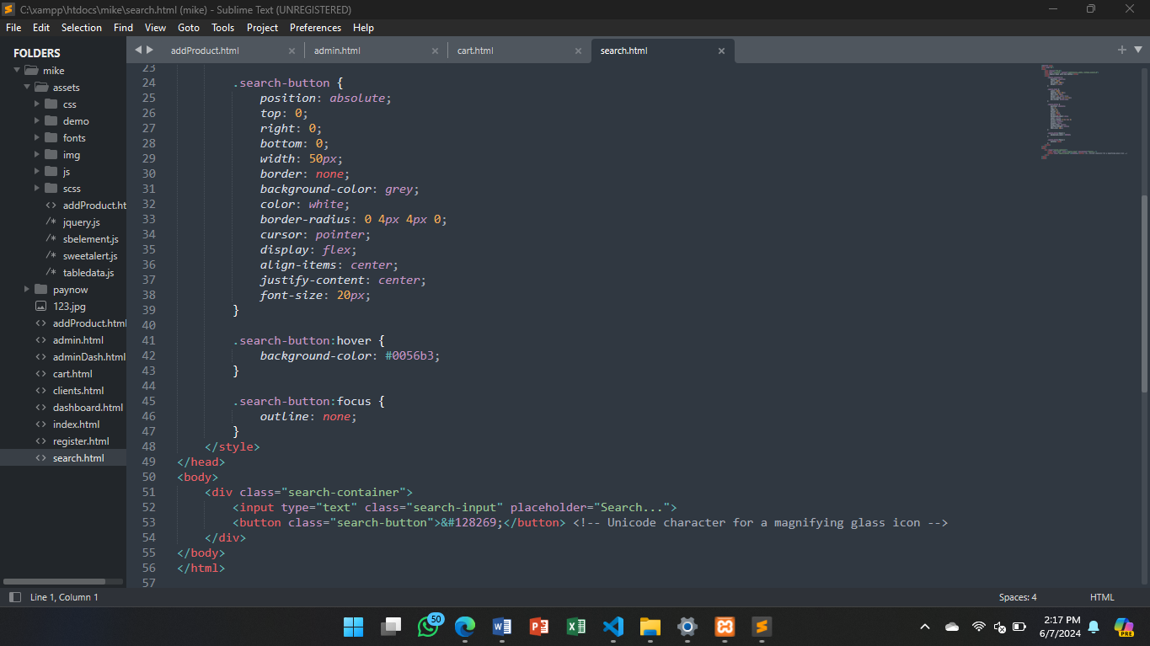 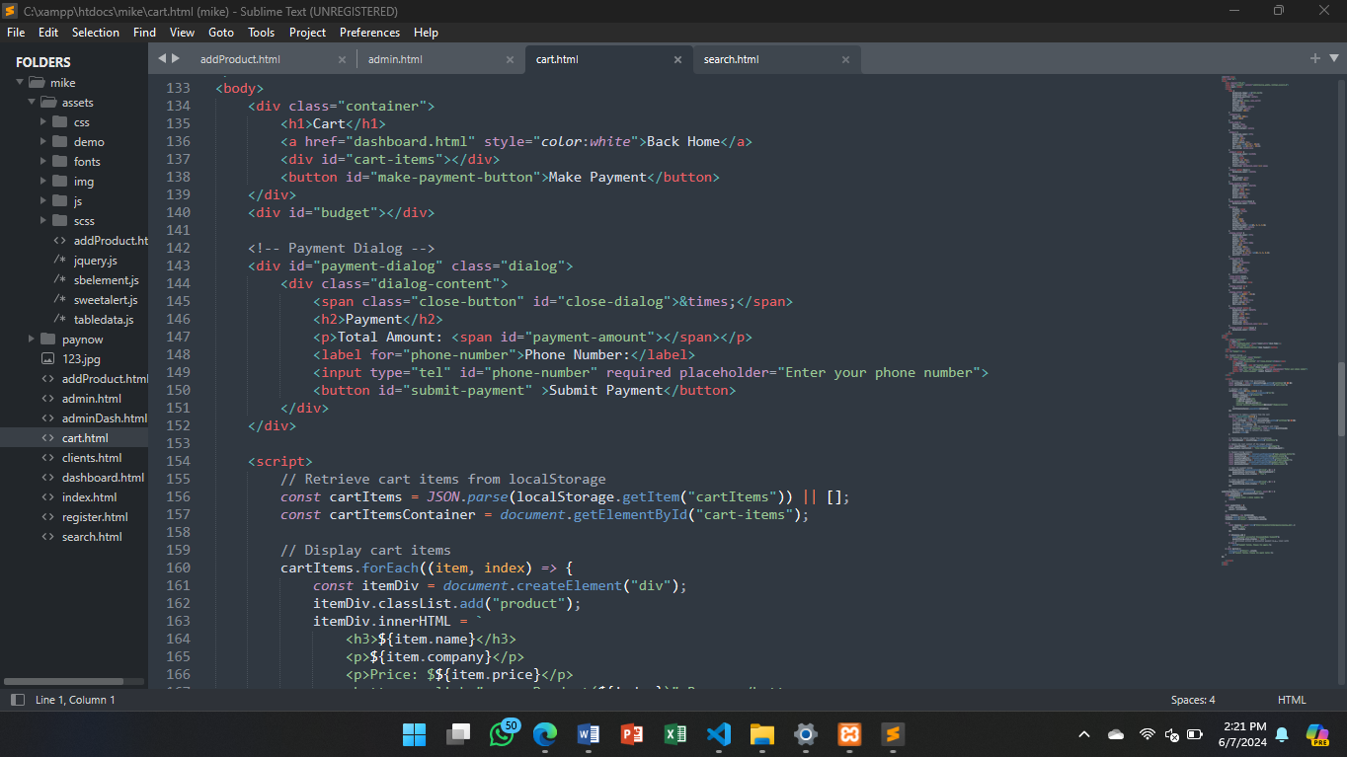 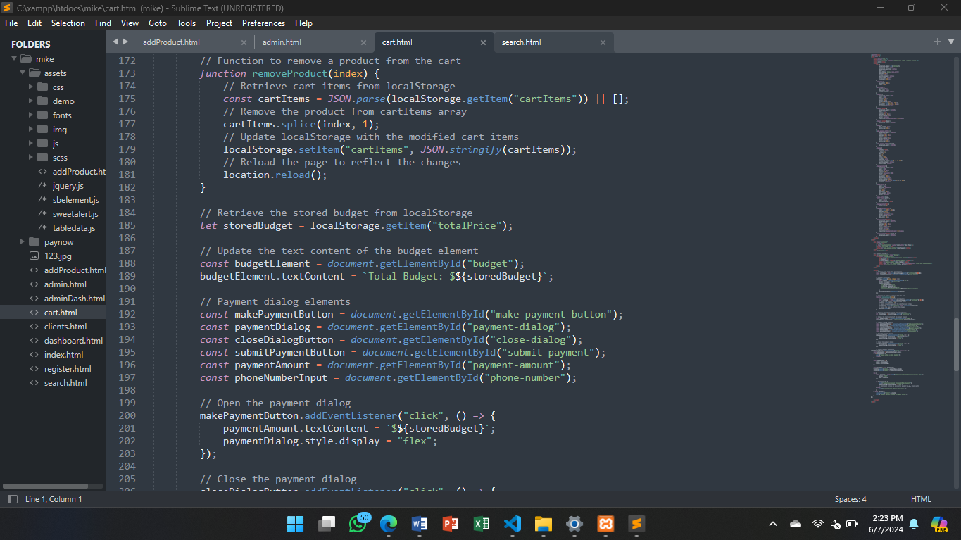 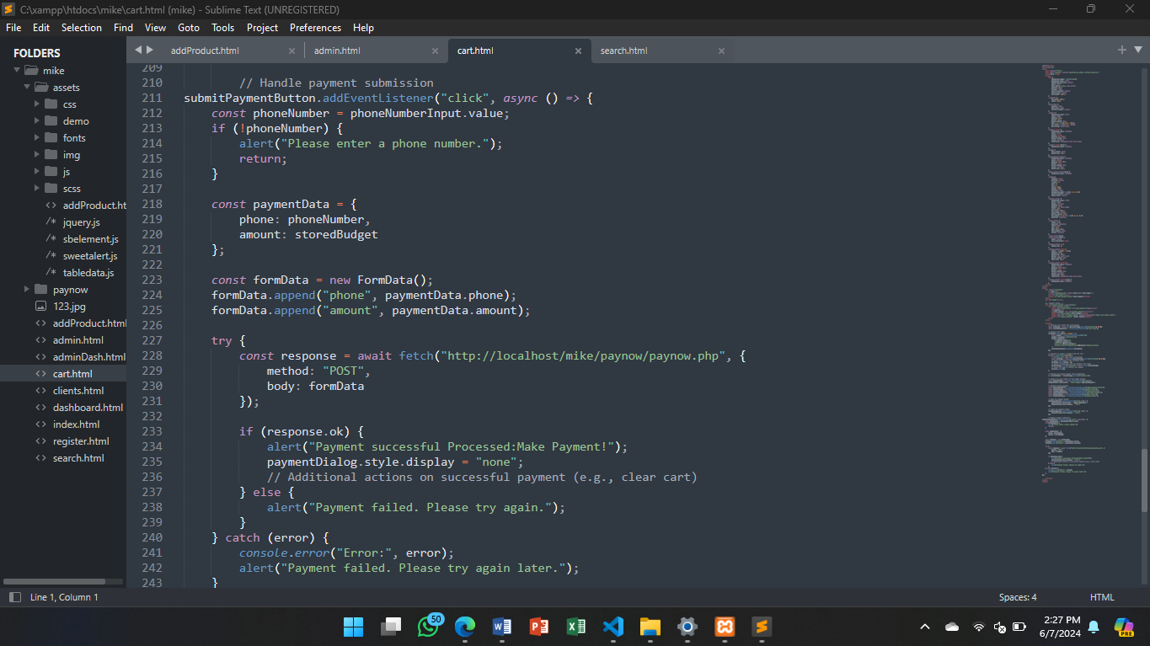 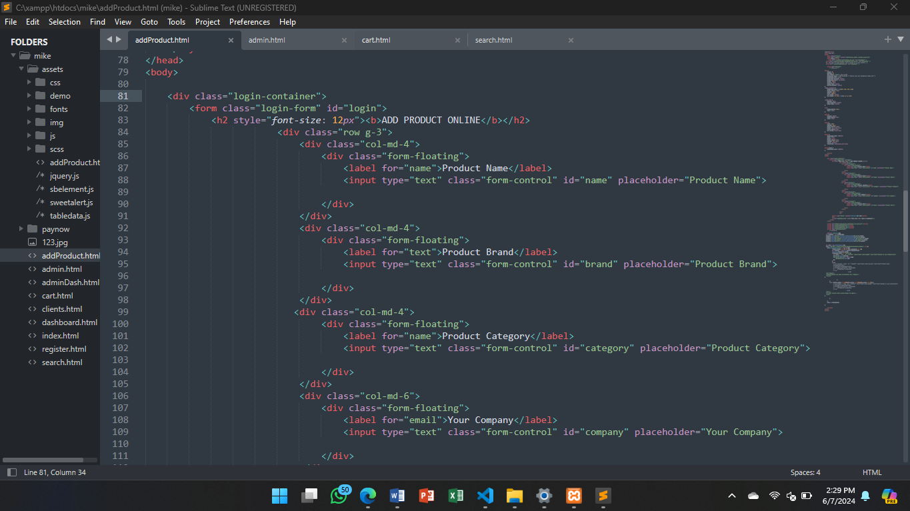 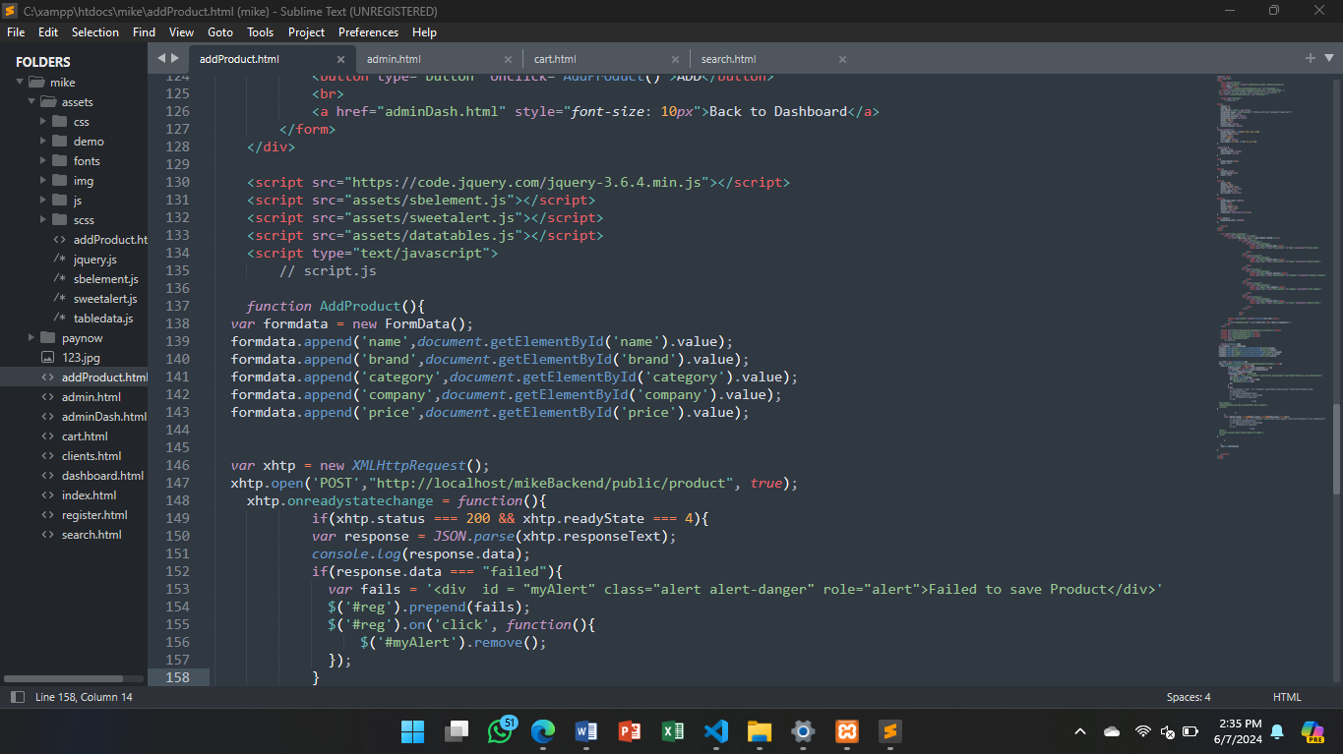 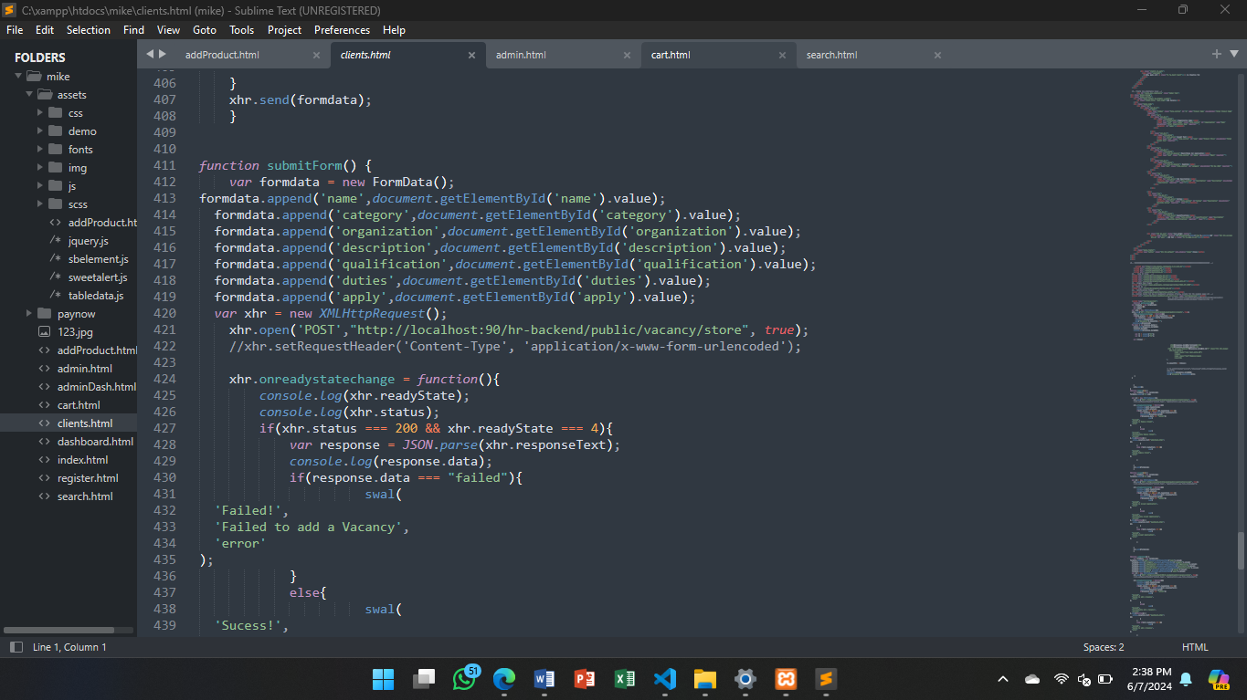

## **4.3 Unit and System Testing: Plans and Results**

This section focuses on user testing, where real users interact with the system to provide feedback.

The dashboard shows the admin side where the admin can add , remove and view all the products that are in the system

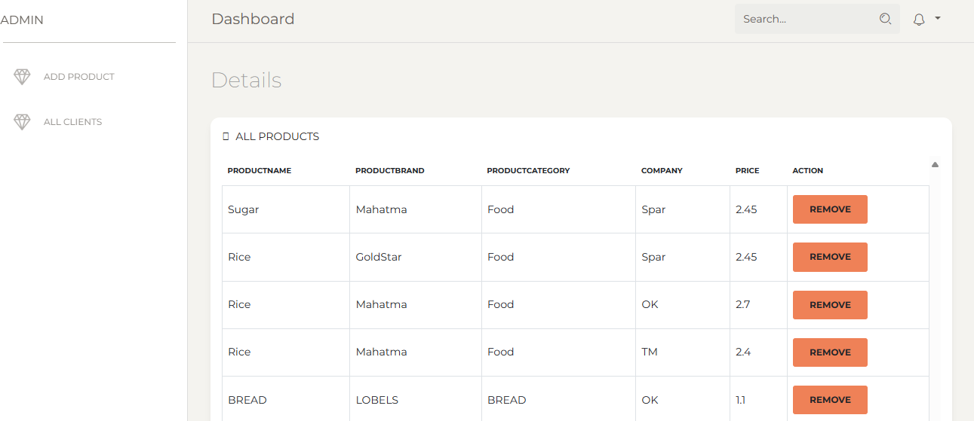

This screenshot shows the admin function that are admins to enter products into to the price comparison system.The admin enters the product name ,brand, category ,company and product price.

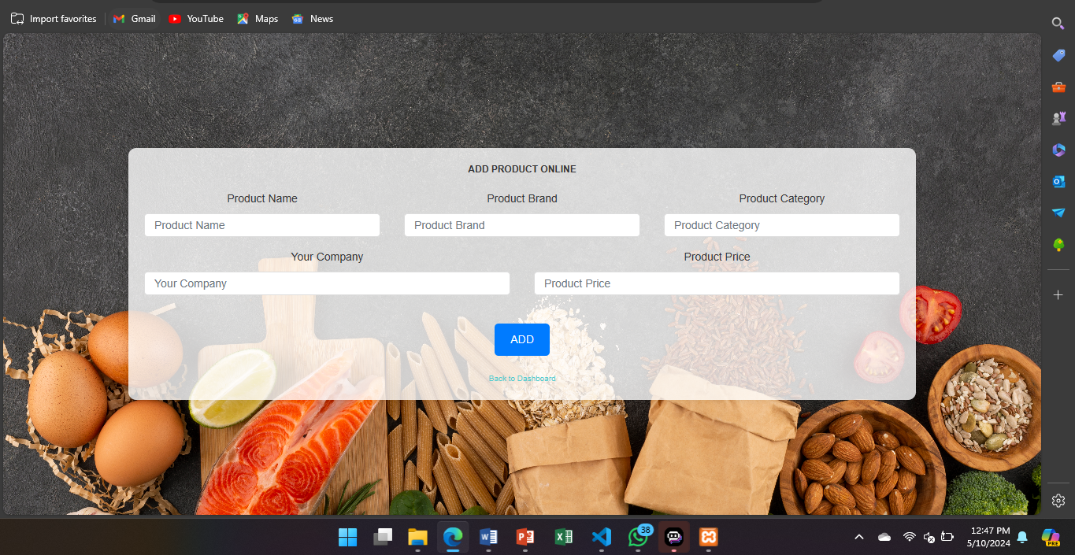

The dashboard shows the admin users that are allowed access and have admin rights to admin account to alter backend data of the price comparison system.

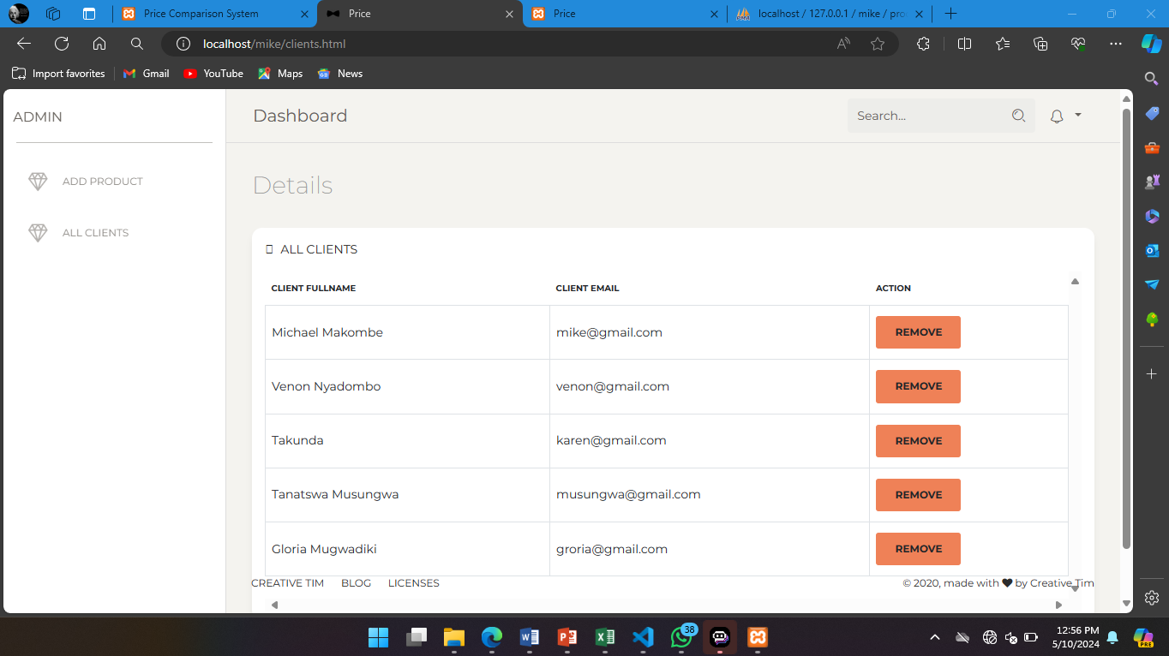

This is the homepage of the price comparison system website for the user. It contains the search space to type,search button and and view cart button.

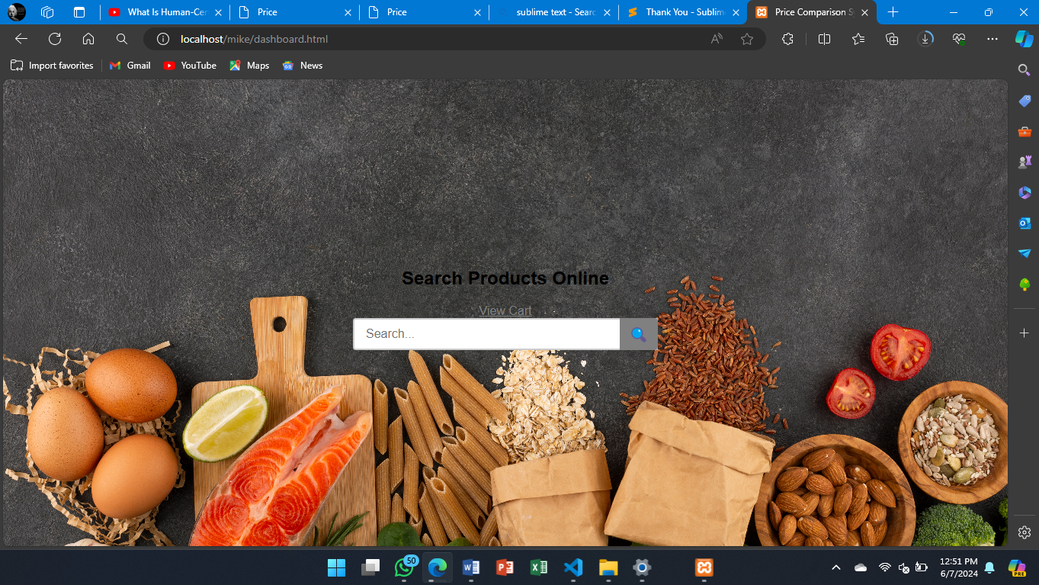

This shows when the user enters the word ‘bread’ and a search list appears of the available options of bread with each option displaying Price ,Company ,Category and Brand . Showing the least to most expensive in the left to right order. It shows an “add to cart “ button to add to the cart

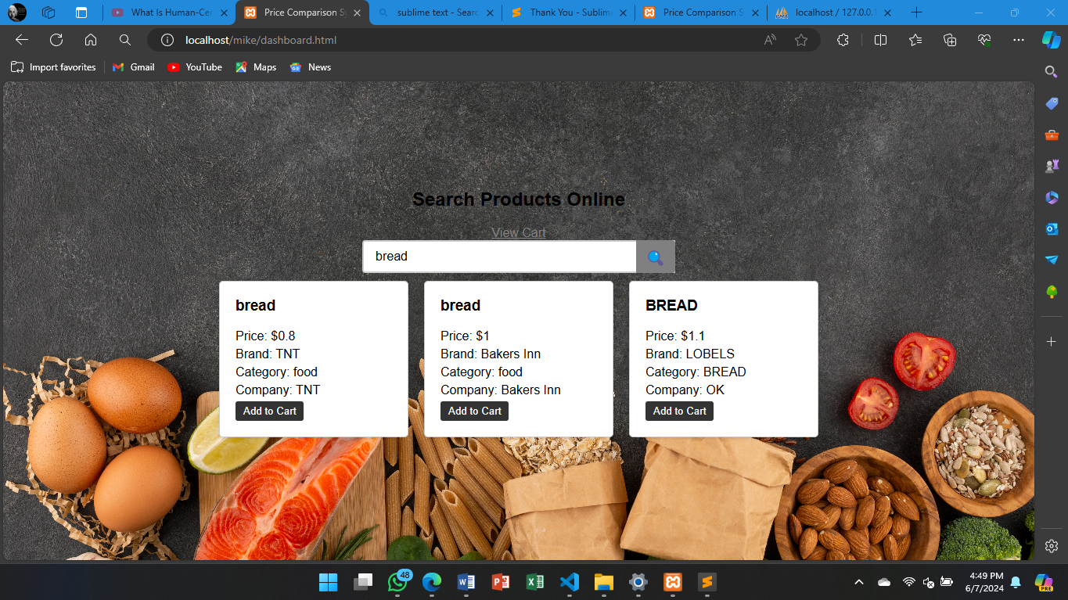

This screenshot another example whereby the user searches for rice

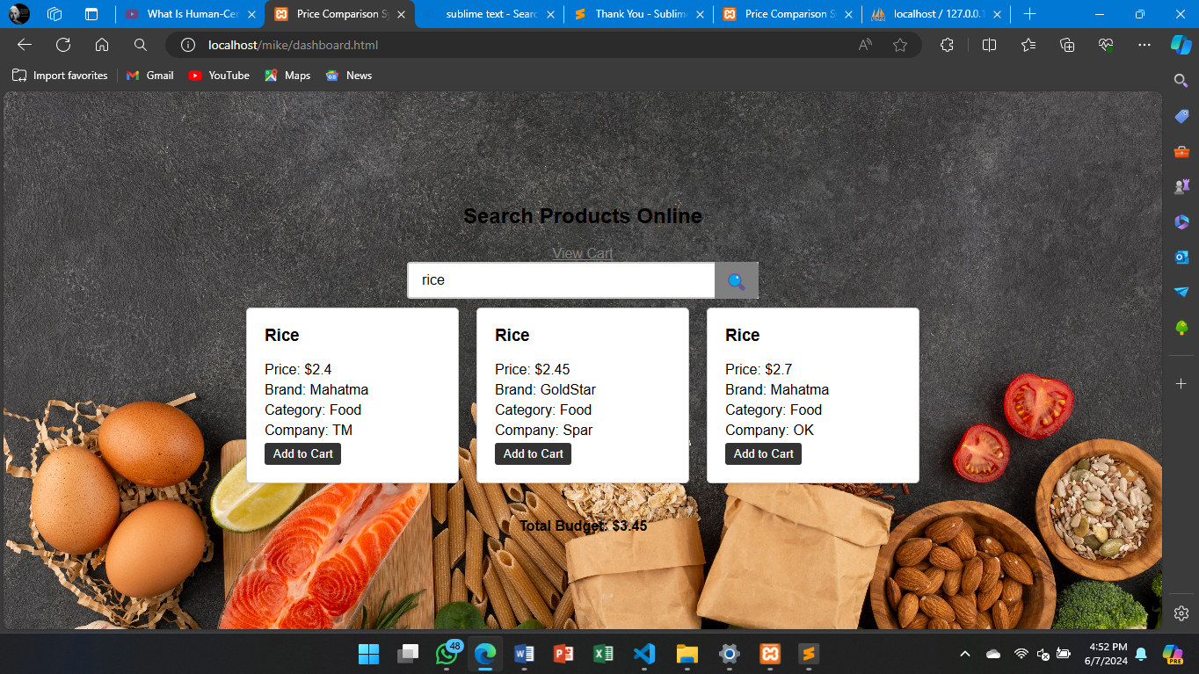

The screenshot shows when the user presses the “Add to Cart” button thereby the sugar option selected is added to the cart

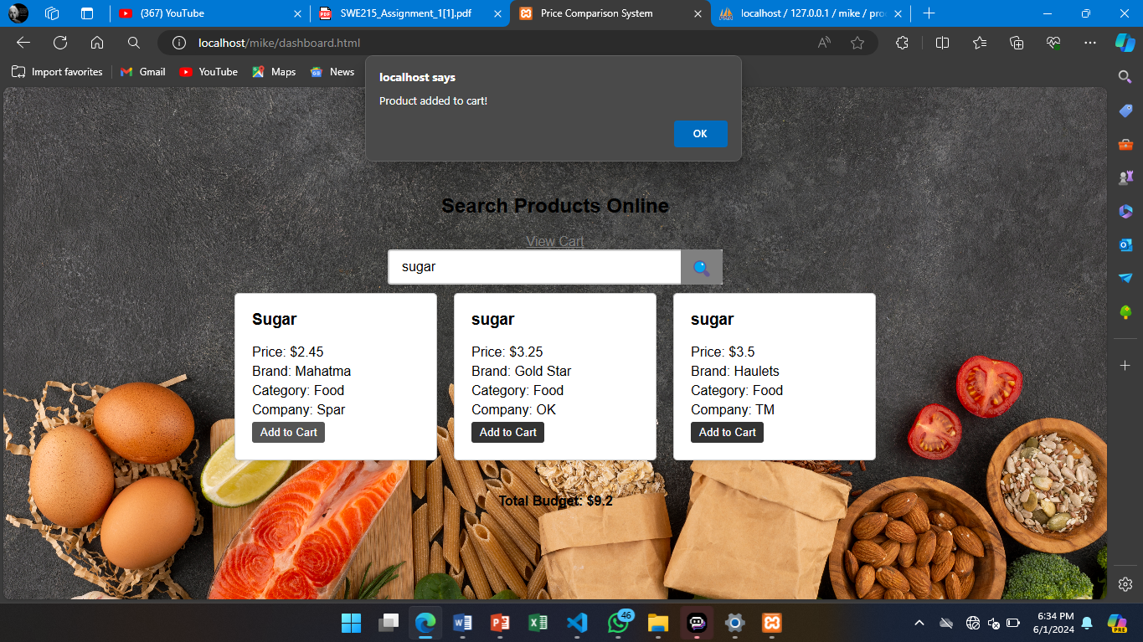

This screenshot shows another example of when the user presses the “Add to Cart “ button on of the options of rice thereby they are added to cart. An alert appears when the rice is added to cart.

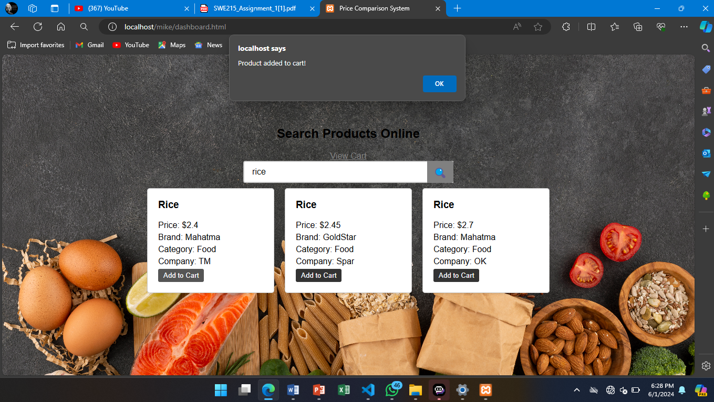

When the user presses the “view cart “ button it shows a list of products that have been added to the cart by user. It shows the total budget on the right. The user has the option to remove products from the cart as well. The green button “make payment “ is the button that initiates the payment for products in the cart.

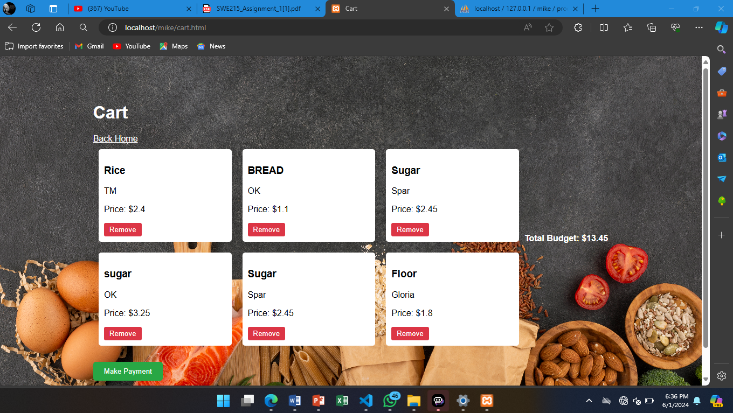

When green button is pressed a prompt showing the total amount appears and requests the user to enter their mobile number so that the mobile payment is initiated. The system uses Ecocash mobile payment.

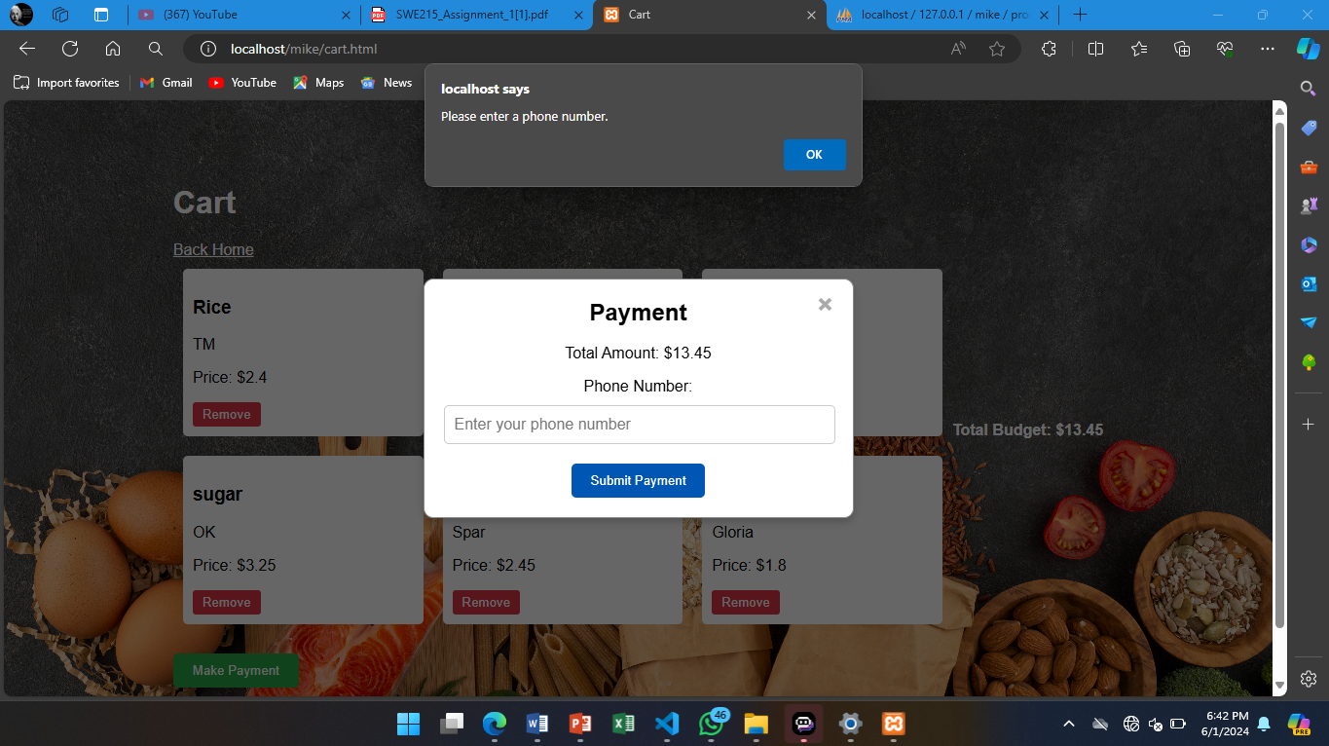

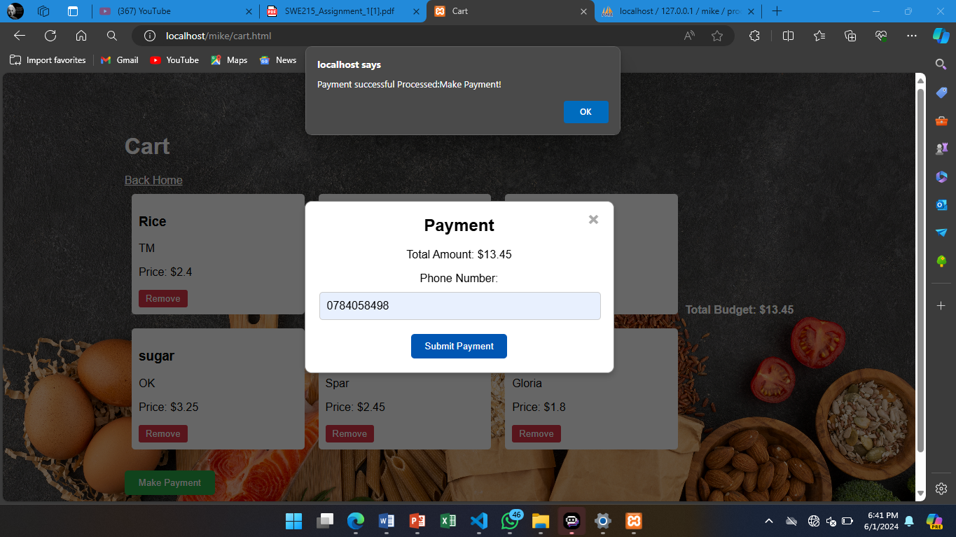

An alert pops up on your mobile number requiring a pin on your phone so that the ecocash payment is authorized to complete the purchase of products.

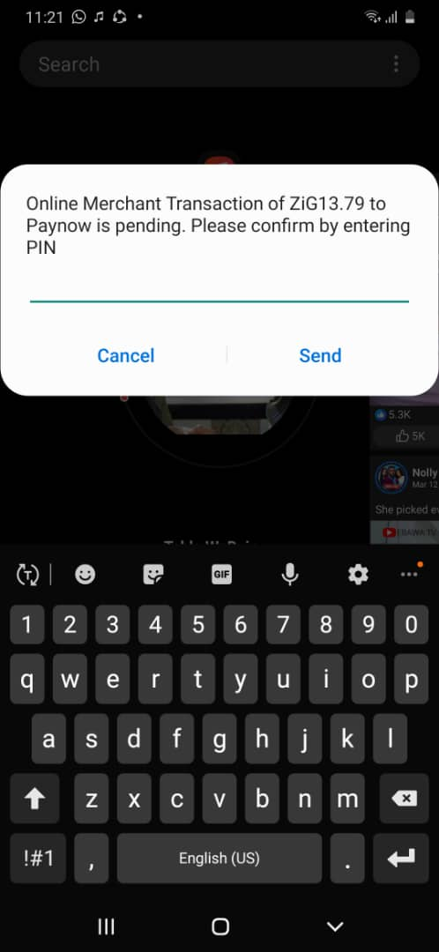

## **4.4 User Testing**

This page shows the admin authentication. It only allows admins that are registered to login into the admin side of the price comparison system

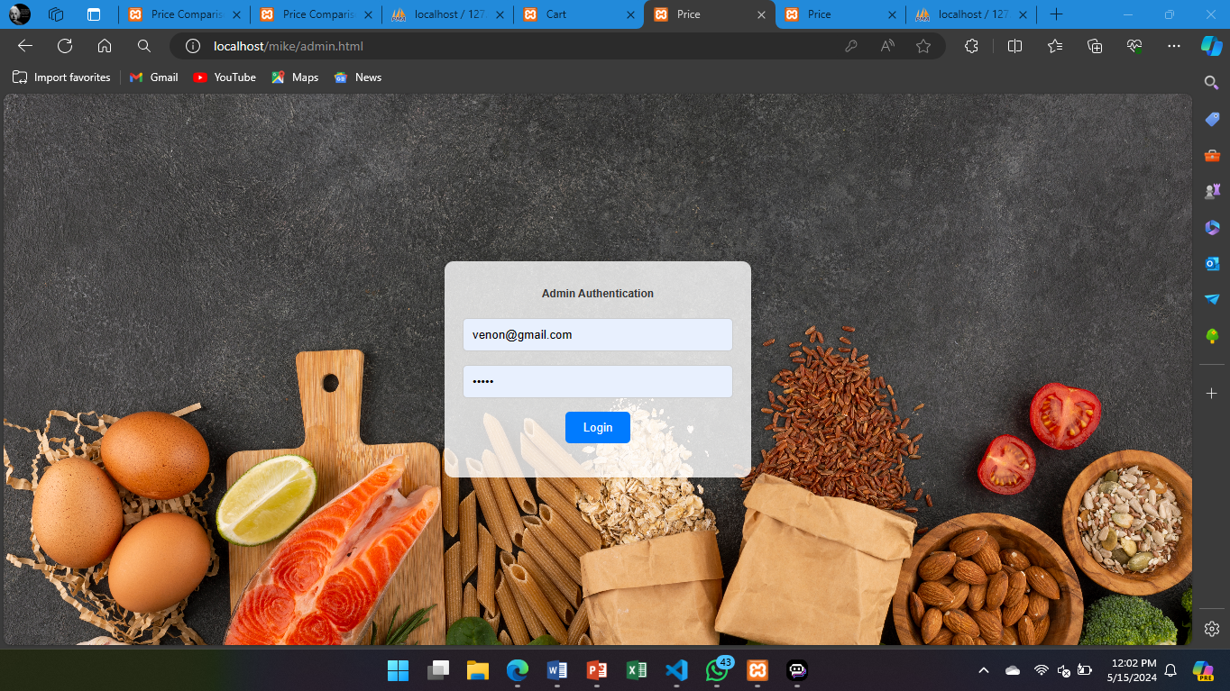

This page shows the registration form for the admin for them to enter so that their credentials are in the system so that they are able to log in the admin account

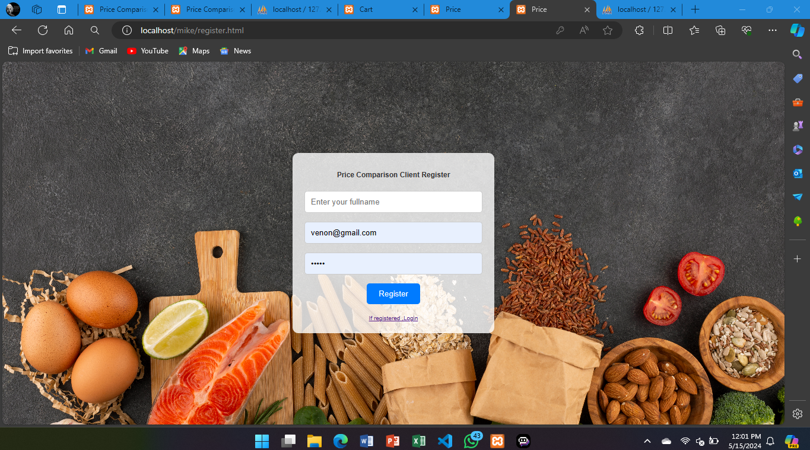

This page shows an unauthorized user trying to log in into the admin account

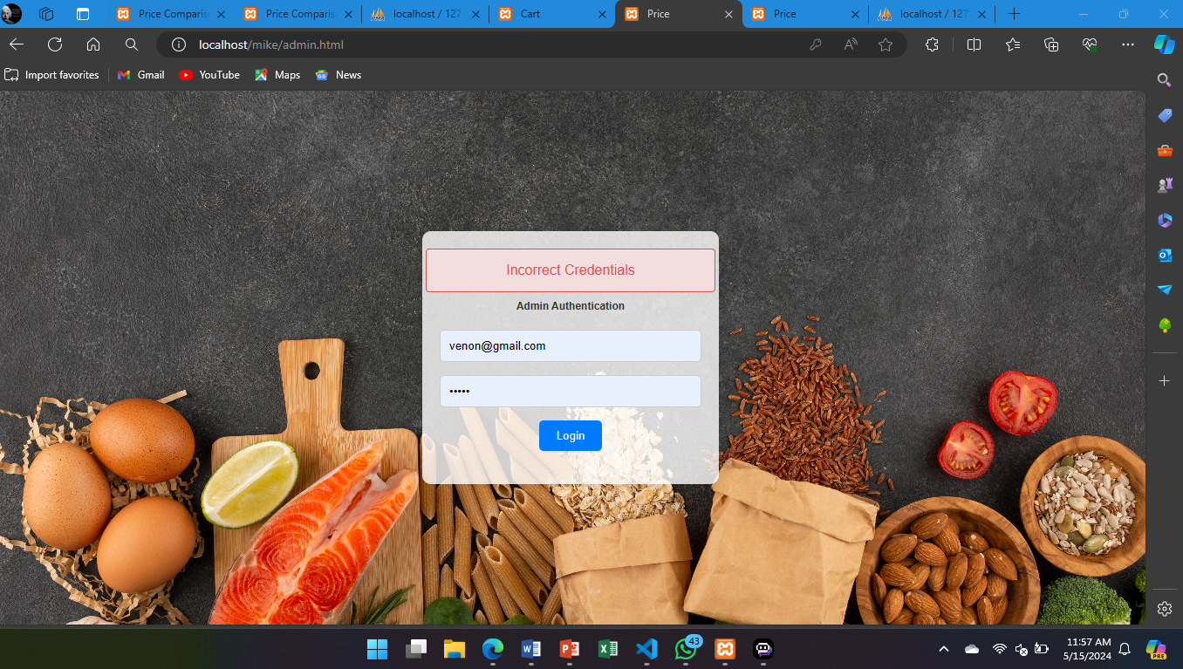

This page shows when system fails to create a client account

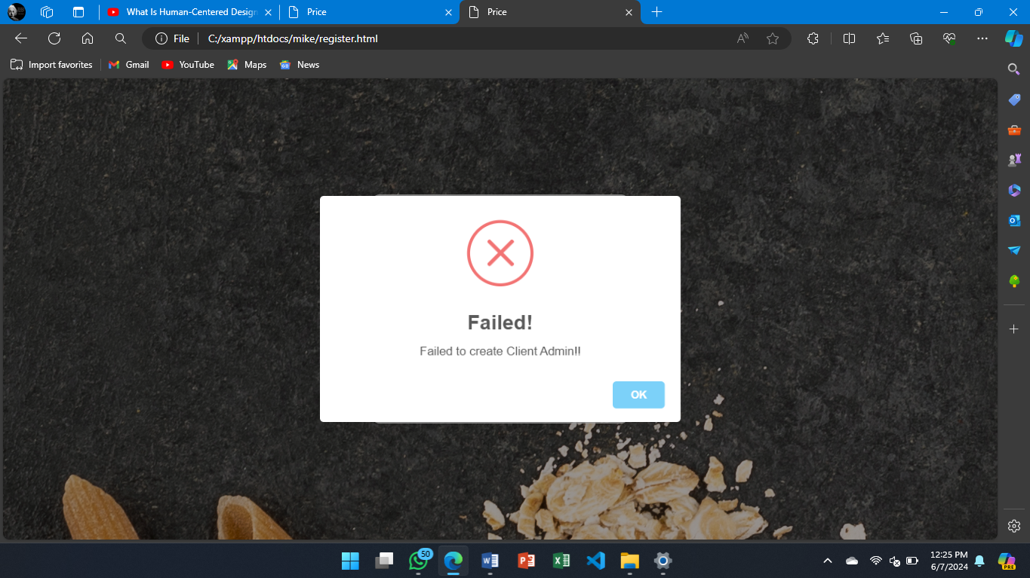

## **4.5 Conclusion**

In Chapter 4, we delved into the coding and testing phases of our Price Comparison System's development. We thoroughly documented the system's code, detailing its architecture, key components, and developer guidelines. Our testing efforts encompassed both unit and system testing, yielding valuable insights into the system's functionality and robustness. User testing sessions provided crucial feedback on usability and user experience, informing future system enhancements. Overall, this chapter highlighted the meticulous approach taken towards ensuring the reliability and effectiveness of our Price Comparison System.

CHAPTER 5 : Implementation & Deployment

5.1 Introduction

This chapter focuses on the implementation and deployment. In this section, we set the groundwork for understanding how the project will be executed and put into action. We will discuss the key objectives, strategies, and considerations involved in bringing the project to life and making it available for users. The chapter sets the context for project implementation and highlights the need for effective organisational structures to manage price comparison projects. It outlines the major topics that will be covered and provides a glimpse into the steps involved in transforming the project from a concept to a functional reality.

5.2 Conversion Plan

A conversion plan is a structured approach to identify and implement the necessary steps to convert a user from a potential customer to a paying customer.

Step 1: Awareness

* Identify the target audience and their needs
* Develop a marketing strategy to reach the target audience (e.g. social media, search engine optimization, email marketing)
* Create engaging content that highlights the benefits of the price comparison system (e.g., saving money, time-saving,)

Step 2: Retention

* Monitor user activity and behavior to identify areas for improvement
* Offer personalized recommendations and suggestions to enhance the user experience
* Implement a loyalty program or rewards system to incentivize users to continue using the price comparison system

Step 3: Conversion

* Offer premium features or services that require payment (e.g., advanced search filters, exclusive deals)
* Highlight the benefits of upgrading to a paid plan or subscription
* Utilize email marketing campaigns to promote paid plans and services

5.3 User Manual

Introduction

The Price Comparison System is a powerful tool designed to help you make informed purchasing decisions by comparing prices of products across various online retailers. This system allows you to easily compare prices and make purchases directly from the platform.

Getting Started

1. To access the Price Comparison System, navigate to our website .

2. Enter your preferred search criteria, such as product name, category, or brand, in the search bar.

3. Click on the "Search" button to initiate the search process.

Searching for Products

1. The search results page displays a list of products that match your search criteria.

2. Each product listing includes essential information such as:

* Product name
* Price
* Product Brand
* Company
* Product Category

Purchasing Products

1. The system will add selected products to the cart

2. To purchase a product directly from the Price Comparison System, click on cart where you can view all the products you selected.You have the option to remove products as well

3. To make the purchase you click "Make Payment" ,a pop up will appear requiring you to enter your phone number for Ecocash wallet then press “Submit Payment”

4. An Ecocash paynow mobile prompt will appear on your phone with submitted number requiring you to complete purchase by entering the pin of Ecocash wallet.

5. After purchase is complete your order will be ready to collect or to be delivered incurring a fee at your desired address.

System Requirements

1. The Price Comparison System is compatible with desktop and mobile devices running Windows 10 or later, macOS High Sierra or later, and iOS 12 or later.

2. A stable internet connection is required to use the system.

Security

1. The Price Comparison System uses industry-standard encryption to ensure secure data transmission and storage.

2. We comply with all relevant data protection regulations and respect your privacy.

By using the Price Comparison System, you acknowledge that you have read and understood this user manual and agree to comply with its terms and conditions.

5.4 User Training: plan

Objective:

To ensure that all users, both customers, and administrators, are able to effectively utilize the features and functionalities of the price comparison system.

Target Audience:

1. Customers: Individuals who will be using the price comparison system to search for and compare products.
2. Administrators: Individuals responsible for managing the system, including data integration, content updates, and analytics.

**Training Phases:**

1. Onboarding and Introduction:

* Develop a comprehensive onboarding guide that covers the overall purpose and benefits of the price comparison system.
* Create a series of tutorial videos or interactive walkthroughs to familiarize users with the system's main features and functionalities.
* Provide clear instructions on how to create an account (if applicable) and customize user preferences.

2. Product Search and Comparison:

* Conduct hands-on training sessions to demonstrate the search and filtering capabilities of the system.
* Explain how to effectively use the various search and sorting options to find the best deals.
* Showcase the side-by-side product comparison feature and how it can help users make informed purchasing decisions.

3. Administrative Training (for Administrators):

* Train administrators on how to manage the backend of the system, including data integration, content updates, and analytics.
* Provide detailed instructions on the process of onboarding new data sources, verifying product information, and ensuring data accuracy.
* Educate administrators on the available analytics and reporting tools, and how to use them to make data-driven decisions.

4. Ongoing Support and Knowledge Base:

* Establish a comprehensive knowledge base or FAQ section on the website to address common questions and issues.
* Provide multiple channels for user support, such as a help center, email, and live chat, to ensure users can get assistance when needed.
* Regularly update the training materials and knowledge base to reflect any changes or new features in the price comparison system.

**Training Delivery Methods:**

* Online tutorials and video demonstrations
* Interactive walkthroughs and hands-on exercises
* Live training sessions (in-person or virtual)
* Written user guides and documentation
* Self-paced e-learning modules

**Evaluation and Feedback:**

* Gather feedback from users on the effectiveness of the training program and the usability of the system.
* Continuously monitor user behavior and engagement to identify areas for improvement or additional training needs.
* Implement a feedback loop to incorporate user suggestions and insights into the development and refinement of the training program.

5.5 Chapter Summary

The chapter covers the critical steps involved in turning a system design into a functional and operational system. It includes detailed processes for ensuring the system meets requirements and performs efficiently in a production environment. It highlights that a successful deployment not only involves technical expertise but also effective communication and coordination among all stakeholders.

Chapter 6 : Evaluation & Conclusion

6.1 Introduction

This chapter delves into to the evaluation and draw conclusions. In this section, we set the context for summarizing findings, making recommendations, and reflecting on the project’s impact. We assess the performance, effectiveness, and user satisfaction of the price comparison system, and draw final conclusions regarding the success and impact of the project, as well as the approach taken to assess the system's performance and gather feedback from users. In summary, the introduction to Chapter 6 sets the stage for evaluating the price comparison project, drawing meaningful conclusions, and shaping future directions.

6.2 Evaluation of the system

Pros

* The price comparison system has the potential to become a valuable resource for consumers who are looking to find the best deals on a wide range of products.
* By aggregating pricing data from multiple online retailers and providing a user-friendly interface, the system can help users make more informed purchasing decisions and save money.
* Comprehensive product coverage and up-to-date pricing information.
* Side-by-side comparisons of prices, discounts, and product details.
* The user interface is simple and easy to use for any beginner as clients only need to search the products they need on the homepage and then will be able to make the purchase at the comfort of their home

Cons

* The system so far only comprises of food products as for future developments it needs to incorporate products such as hardware and clothes in the future.
* Limited coverage: The system is not yet able to cover all online retailers, which could lead to incomplete or inaccurate information. The retailers need to willingly submit their data
* Outdated data: Prices may not be updated in real-time, which could lead to inaccuracies or missed sales.
* Limited product range: The system may only cover a limited range of products, which could be frustrating for users who are looking for more specific products.
* Data accuracy: The accuracy of the data provided by the system is crucial, but errors can occur if the data is not properly collected or updated.
* Some stores and clients may not be able to use modern technologies such as price comparison system as the prefer doing business physically which could lead to fewer people using the price comparison system

Recommendations:

1. Improve data accuracy: Ensure that prices are up-to-date and accurate by implementing regular updates and double-checking data.

2. Enhance user experience: Improve the user interface and make it more user-friendly to ensure that users can easily navigate and find the information they need.

3. Expand product range: Expand the product range covered by the system to include more products and categories.

4. Improve technical issues: Address any technical issues or glitches that may affect the system's performance.

5. Monitor and adjust: Continuously monitor the system's performance and adjust accordingly based on user feedback and market trends.

6.3 Future plans/developments

1. Expand Data Sources and Integrations:

Integrate with more online retailers and marketplaces to expand product coverage and provide users with a comprehensive comparison experience. Develop automated scripts or utilize web scraping tools to continuously update pricing and product information from various sources. Implement APIs or webhooks to receive real-time updates from e-commerce platforms, ensuring the data is always up-to-date.

2. Advanced Filtering and Sorting:

Enhance the search and filtering capabilities to allow users to narrow down results based on more detailed criteria, such as brand, category, customer ratings, and shipping options. Implement advanced sorting algorithms to help users quickly identify the best deals based on a combination of factors, such as price, discounts, and customer reviews.

3. Personalization and Recommendations:

Develop a user account system to allow customers to save their preferences, track price changes, and receive personalized product recommendations. Utilize machine learning algorithms to analyze user behaviour and browsing history to provide more accurate and relevant recommendations. Implement features like price alerts and price drop notifications to help users stay informed about their desired products.

4. Mobile App Development:

Create a mobile application for the price comparison system to provide a seamless on-the-go experience for users. Leverage mobile-specific features, such as barcode scanning, location-based recommendations, and push notifications, to enhance the user experience.

5. Analytical and Reporting Tools:

Develop an administrative dashboard to provide website operators with insights into user behavior, product performance, and market trends. Implement advanced analytics and reporting capabilities to help identify opportunities for improvement, optimize marketing strategies, and make data-driven decisions.

* To ensure the long-term success of the system, it will be important to continuously expand the data sources, improve the user experience, and leverage advanced technologies like machine learning and data analytics.

6.4 Chapter Summary

The price comparison system presented in this proposal provides a solid foundation for a powerful and user-friendly tool that can help consumers save money and make better purchasing decisions. By implementing the proposed future plans and developments, the system can evolve to become an indispensable resource for online shoppers, while also providing valuable insights and analytics for website operators.

As the e-commerce landscape continues to grow and evolve, the price comparison system will need to adapt and innovate to stay ahead of the curve. By focusing on data integration, personalization, and advanced features, the system can establish itself as a leading player in the price comparison market and provide significant value to both consumers and businesses.